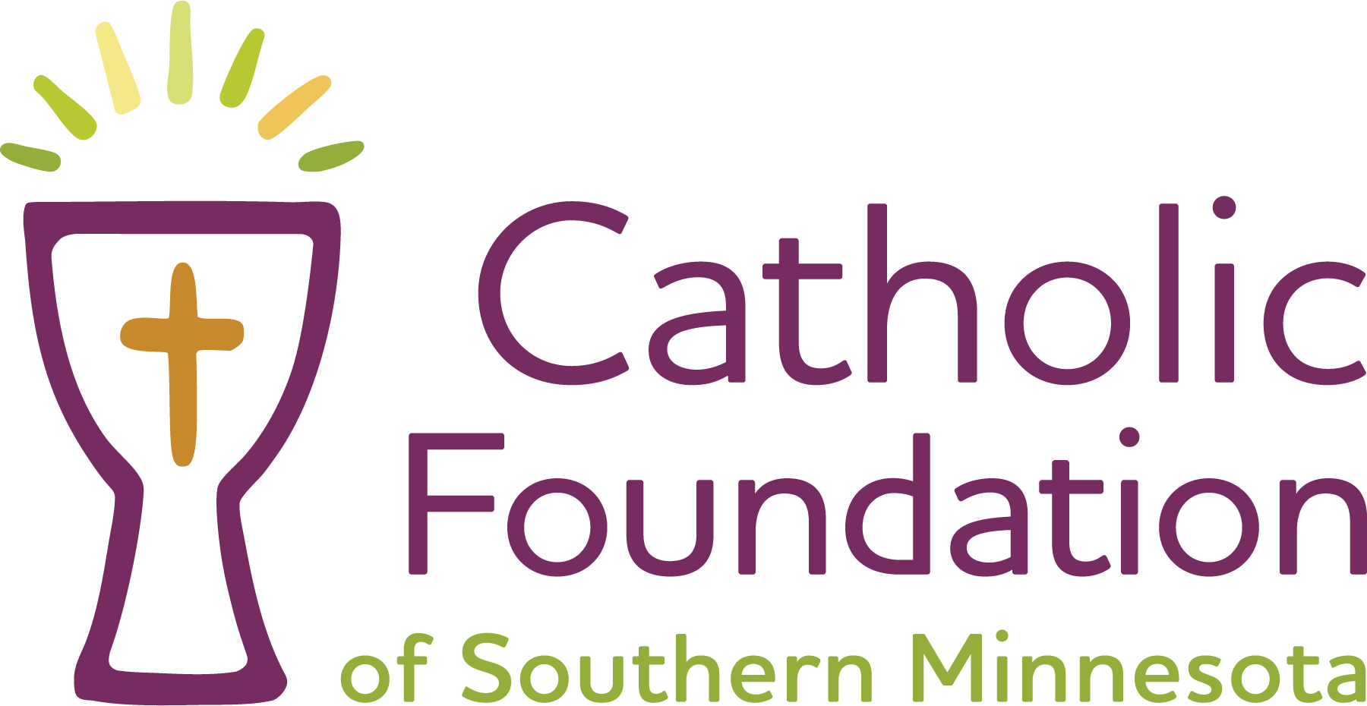
GIFT INSTRUMENT
BETWEEN CATHOLIC FOUNDATION OF SOUTHERN MINNESOTA
AND [Insert Donor Name(s)]
[DONOR NAME(S)] (individually or collectively, “Donor”) and Catholic Foundation of Southern Minnesota, a Minnesota nonprofit corporation (“CFSM”), enter into this Gift Instrument effective as of [DATE] to establish the [NAME OF FUND] (the “Fund”). CFSM agrees to accept, hold, invest, administer, and distribute the Fund in accordance with this Gift Instrument and applicable law.
WHEREAS, Donor desires to establish a permanent charitable endowment fund to provide long-term financial support for the charitable purposes described herein; and
WHEREAS, CFSM agrees to hold and administer the Fund as an endowment in accordance with this Gift Instrument and applicable law.
1. Property of the Fund. The Fund shall consist of the initial contribution described below, together with any additional contributions accepted by CFSM and designated for the Fund, and all income, appreciation, proceeds, and other additions attributable to those assets. Each contribution to the Fund is irrevocable when accepted by CFSM. CFSM shall have exclusive legal ownership and control of all assets of the Fund, subject to the restrictions stated in this Gift Instrument.
2. Charitable Purpose. Subject to the limitations set forth herein, the purpose of the Fund is to further the religious and charitable purposes of the Catholic Foundation of Southern Minnesota ("CFSM") by establishing a restricted charitable endowment fund to provide perpetual support for the following charitable purpose:
[DESCRIBE THE SPECIFIC PURPOSE]
(the "Charitable Purpose").
The Fund is intended to exist in perpetuity. Distributions shall be made only in accordance with Section 4 of this Gift Instrument and CFSM's then-current endowment spending policy.
3. Initial Contribution and Additional Gifts. The Fund shall be established with an initial irrevocable contribution from Donor in the amount of $______________. Additional contributions from Donor or any other person or entity may be accepted by CFSM and added to the Fund at any time, provided that each contribution is consistent with the purpose and terms of this Gift Instrument and CFSM’s then-current Gift Acceptance Policy. CFSM may decline any proposed contribution in its discretion in accordance with its then-current Gift Acceptance Policy.
4. Distributions. The Fund is intended to be a permanent endowment. CFSM shall manage and invest the Fund to preserve its long-term purchasing power while making prudent annual appropriations for expenditure in accordance with its spending policy and the Uniform Prudent Management of Institutional Funds Act. Nothing in this Gift Instrument is intended to prohibit an appropriation from the Fund to the extent permitted by applicable law.
CFSM shall determine the amount available for distribution each year in accordance with its then-current endowment spending policy, as adopted and amended from time to time by its Board of Directors, and consistent with the Uniform Prudent Management of Institutional Funds Act, Minn. Stat. §§ 309.73 through 309.77.
Distributions from the Fund shall be used solely for the Charitable Purpose described in Section 2.
5. Administration and Investment. CFSM shall administer the Fund as follows:
a. Commingling and Accounting. CFSM may commingle Fund assets with other assets for investment and administrative purposes, but shall maintain separate accounting records sufficient to identify the Fund’s assets, receipts, expenses, and distributions.
b. Investment Management. CFSM shall invest and manage the Fund in accordance with its then-current investment policies and applicable law. CFSM may retain investment managers, custodians, advisors, and other agents as it considers appropriate.
c. Fees and Expenses. CFSM may assess reasonable administrative and investment management fees against the Fund in accordance with its standard fee schedule, as amended from time to time.
d. Reliance on Information. CFSM may rely on information supplied by Donor, the charitable beneficiary, and other persons reasonably believed to be reliable, without independent investigation, unless CFSM has actual knowledge that the information is materially inaccurate.
6. Variance Power and Changed Circumstances. If, in the judgment of the Board of Directors of CFSM, the Charitable Purpose of the Fund becomes unlawful, impossible, impracticable, incapable of fulfillment, or wasteful, or if continued administration of the Fund according to its terms would become inconsistent with the mission of CFSM, CFSM may modify the restriction on the use of the Fund in a manner that most nearly accomplishes Donor's original charitable intent, consistent with applicable law.
7. No Donor Control; No Private Benefit. Donor may provide nonbinding information or recommendations concerning the Fund, but Donor retains no right to direct investments, compel distributions, recover any contribution, or otherwise control Fund assets. No distribution shall be made for the private benefit of Donor or any other person except as permitted by applicable federal and state tax law.
8. Fund Is Not a Separate Trust or Entity. The Fund is an accounting fund of CFSM and does not constitute a separate trust, foundation, or legal entity. CFSM holds the Fund as beneficial owner and not as trustee for Donor or any charitable beneficiary.
9. Tax Status and Receipts. CFSM intends that contributions accepted for the Fund qualify as charitable contributions to the extent allowed by law. CFSM shall provide acknowledgments in accordance with its customary practices, but makes no representation or warranty concerning the tax consequences of any contribution. Donor is responsible for obtaining independent tax and legal advice and any appraisal required by law.
10. Governing Law; Gift Instrument. This document is a “gift instrument” within the meaning of the Uniform Prudent Management of Institutional Funds Act, Minnesota Statutes sections 309.73 through 309.77, as amended. This Gift Instrument constitutes the entire agreement concerning the Fund and supersedes all prior oral or written understandings concerning it. Minnesota law governs this Gift Instrument and the Fund.
11. Independent Nonprofit Corporation. CFSM is a nonprofit corporation independent of and separate from any parish, school, diocese, ministry, or other organization. All contributions become the sole property of CFSM, subject only to the restrictions contained in this Gift Instrument, subject to the direction and control of its independent Board of Directors and the restrictions expressly stated in this Gift Instrument.
12. Amendment. This Gift Instrument may be amended during Donor’s lifetime only by a written instrument signed by Donor and CFSM, provided that no amendment may permit a return of contributed assets to Donor, confer a prohibited private benefit, or otherwise violate applicable law. After Donor’s death or incapacity, CFSM may administer or modify the Fund only as authorized by this Gift Instrument and applicable law.
13. Counterparts and Electronic Signatures. This Gift Instrument may be signed in counterparts, each of which is deemed an original, and signatures transmitted electronically or by electronic-signature platform shall be effective to the extent permitted by law.
The parties have executed this Gift Instrument as of the dates stated below.
DONOR  __________________________________  [DONOR NAME]  Date: ____________________________  OPTIONAL: ADDITIONAL DONOR  __________________________________  [DONOR NAME]  Date: ____________________________ | CATHOLIC FOUNDATION OF SOUTHERN MINNESOTA  __________________________________  By: Elizabeth Williams  Title: Executive Director  Date: ____________________________
Template Notes:
- Bracketed language should be completed or deleted.
- The purpose clause should identify the charitable use with enough specificity to administer the Fund while avoiding unnecessary operational detail.

