Announcing 2021-2022 Scholarship Program

Charles I. Passe Endowment Fund

Dear Parishioners of Saint Felix, Saint Agnes, and Immaculate Conception parishes,

Several years ago, Mr. Charles I. Passe, through his estate, established an endowment fund with the Catholic Foundation of Southern Minnesota to fund scholarships to qualified students seeking higher education. The Board of Directors of the Catholic Foundation of Southern Minnesota, in exercising stewardship of this endowment, has established a process for awarding funds from the endowment. This year, up to $46,700 is available for qualified students.

Funds from the Charles I. Passe Endowment Scholarship will be awarded in the following order:

- Saint Felix parishioners enrolled in a diploma and/or certificate program at a trade/technical school,
- Saint Felix parishioners enrolled in an Associate’s degree program at a trade/technical school,
- Cluster parishioners enrolled in a diploma and/or certificate program at a trade/technical school, or
- Cluster parishioners enrolled in an Associate’s degree program at a trade/technical school.

In the rare event that funds remain after all applications in these categories have been processed, the Catholic Foundation of Southern Minnesota will consider other scholarship requests (i.e., Bachelor’s degree programs). All awards are made by the Catholic Foundation of Southern Minnesota.

Applications will be available starting on April 4, 2021, at the St. Felix, St. Agnes and Immaculate Conception parish offices and websites, the Wabasha-Kellogg and Plainview-Elgin-Millville High School counselor’s offices, and on the Catholic Foundation of Southern Minnesota website at www.catholicfsmn.org/granting.

ALL APPLICATIONS MUST BE RETURNED TO:

Catholic Foundation of Southern Minnesota
750 Terrace Heights, Suite 105
PO Box 30098
Winona MN 55987

Applications must be received by 4:30pm on Friday, May 21, 2021. Notification of awards will be made no later than June 30, 2021.

Sincerely,
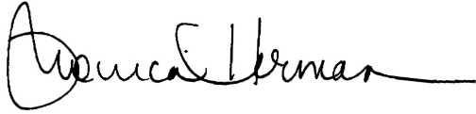

Monica Herman
Executive Director
Catholic Foundation of Southern Minnesota

