Announcing 2019-2020 Scholarship Program

Charles I. Passe Endowment Fund

Dear Parishioners of Saint Felix, Saint Agnes, and Immaculate Conception parishes,

Several years ago, Mr. Charles I. Passe, through his estate, established an endowment fund with the Catholic Foundation of Southern Minnesota to fund scholarships to specific institutions of higher education. The Board of Directors of the Catholic Foundation of Southern Minnesota, in exercising stewardship of this endowment, has established a process for awarding funds from the endowment. This year, up to $46,200 is available for qualified students.

Funds from the Charles I. Passe Scholarship Endowment will be awarded in the following order:

- Saint Felix parishioners enrolled in a diploma and/or certificate program at a trade/technical school,
- Saint Felix parishioners enrolled in an Associates program at a trade/technical school,
- Cluster parishioners enrolled in a diploma and/or certificate program at a trade/technical school, or
- Cluster parishioners enrolled in an Associates program at a trade/technical school.

In the rare event that funds remain after all applications in these categories have been processed, the Catholic Foundation of Southern Minnesota will consider other scholarship requests (i.e., bachelor degree programs). All awards are made by the Board of Directors of the Catholic Foundation of Southern Minnesota.

Applications will be available starting on April 6th at the St. Felix, St. Agnes and Immaculate Conception parish offices and websites, at the Catholic Foundation of Southern Minnesota office, and the Wabasha-Kellogg High School counselor’s office.

ALL APPLICATIONS MUST BE RETURNED TO:

Catholic Foundation of Southern Minnesota
750 Terrace Heights, Suite 105
PO Box 30098
Winona MN 55987

Applications must be received by 4:30 pm Friday, May 17, 2019. Notification of scholarship awards will be made no later than June 15, 2018.

Sincerely,
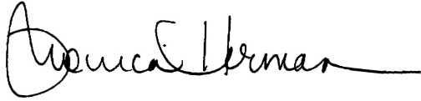

Monica Herman
Executive Director
Catholic Foundation of Southern Minnesota

