Stewardship is Discipleship

USCCB’s Pastoral Letter “Stewardship: A Disciple’s Response”(1993) describes stewardship as “an expression of discipleship” and remind us that “once one chooses to become a disciple of Jesus Christ, stewardship is not an option.”
The letter reminds us that Christian stewardship means we:
- Receive God’s gifts gratefully
- Cultivate them responsibly
- Share them lovingly with others
- Return them with increase to God

The “Priest” of the priest’s role.
What role does stewardship play as a way of making holy?

How often are we discussing this with our parishioners?

The “King” of the priest’s role.
Are we managing parish resources proactively and wisely?

Have we buried our parish talents? Or have we put them to work for the long-term health of the parish? (Parable of the Talents, Matthew 25)

The “Prophet” of the priest’s role.
What level of understanding does our parish have about stewardship?
Is stewardship lived out?

If not well enough, what can we learn from other priests and deacons about how to improve stewardship?

Imagine If
What does stewardship look like at its best in your parish?

What steps would need to be taken to get there?

Get Practical: Fundraising Communications
- Be direct and transparent
- Use visuals
- Tell a story
- Tie the need to an outcome if at all possible. (Get creative if needed!)
- Give one clear next step

Example case statement:
Our parish needs your help to complete an important accessibility project. The front sidewalk has deteriorated to the point where it is difficult for older parishioners, families with strollers, and anyone using canes or wheelchairs to enter the church safely. The current handicap door is also failing, which means some parishioners cannot enter the building without assistance. It will cost us approximately $22,000 to complete the project and we’d like to raise that by May so that we can do the installation after school so there is less traffic. (1, 2)
Picture your grandmother trying to steady herself on a cracked sidewalk, or a parishioner in a wheelchair waiting outside because the automatic door will not open. (3) When we repair the sidewalk and install a reliable handicap door, we make it possible for every person to enter the church with dignity. This is a simple project with a profound outcome: a parish where all can worship. (4)
Your gift today will help us begin the work. Please make a contribution to the Sidewalk and Handicap Door Campaign by giving online, during the collection or dropping a gift in the parish office. Your generosity will help ensure that every person can enter our church safely and confidently. (5)
[Insert photos here]

Let’s Try it Together:
Write a sample case statement for a fundraising need you have, had in the past or may in the future.

Get Practical: Natural Ties to Support Stewardship in Liturgical Year
1. Advent
A season of preparation, hope, and intentional reflection. Parishioners are already thinking about what matters most, making it a natural time to talk about planning for the future, gratitude, and leaving a legacy for the next generation.
2. Christmas Season
A time of generosity, family, and celebrating God’s greatest gift. Many parishioners are open to conversations about giving, gratitude, and supporting the parish that has shaped their family’s faith.
3. Feast of the Holy Family
Perfect for discussing legacy, family values, and stewardship as a gift passed from one generation to the next.
4. Lent
A season of sacrifice, conversion, and deeper discipleship. Stewardship fits naturally here because giving is a sacrificial act that sanctifies and draws us closer to Christ.
5. Easter Season
A time of renewal, new life, and mission. Ideal for talking about how legacy gifts strengthen the Church’s mission and help it flourish long into the future.
6. Pentecost
The birth of the Church and the sending of disciples. A strong moment to speak about stewardship as missionary discipleship and how planned gifts empower the parish’s long-term evangelizing work.
7. Parish Anniversary or Dedication Feast Day
A natural moment to reflect on the parish’s history and invite parishioners to help secure its future.
8. Stewardship Sunday or Annual Appeal Season
Many dioceses designate a weekend for stewardship preaching. This is an ideal time to normalize legacy giving as part of a mature Catholic stewardship life.
9. All Souls Day
A gentle, pastoral moment to talk about legacy, remembrance, and the hope of eternal life. Many Catholics update their estate plans during this season.

Parish Finances Survey – Please Return to Elizabeth Williams

The Foundation is implementing a 2030 Strategic plan, working towards addressing the most timely needs of the people of our diocese today. As a part of measuring the success of our programs, our Board, including Bishop Barron, has asked us to benchmark the current state of the diocese around long-term financial stability.
PLEASE ANSWER 2 QUESTIONS IN YELLOW
- Would you please weigh in?
How often do you, your trustees and/or your finance council use time horizons (explained below) to help you discuss/plan/implement your parish/school/cemetery financial plans?

Never used before Sometimes we consider it Often Always

What Are Time Horizons?
Using Time Horizons means selecting your account type / investment strategy for a particular group of money based on when you expect to need/use the money.
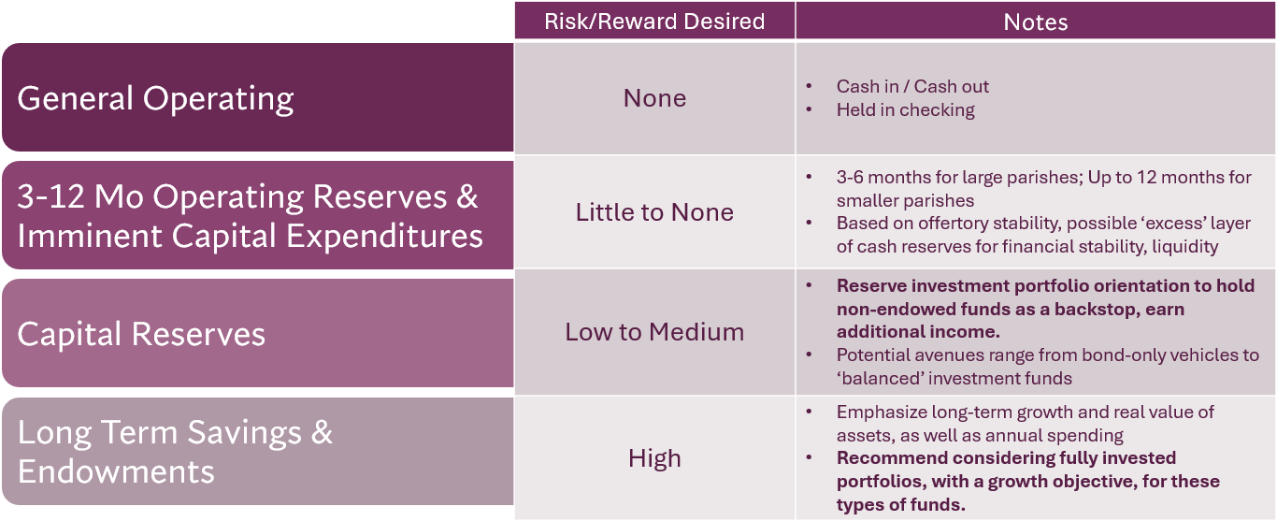

- Please list your email address if you would like to receive our monthly enewsletter with practical articles to help with finances.
____________________________________________________________________

